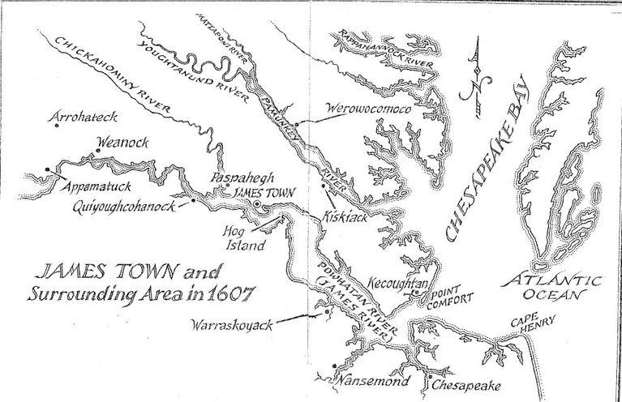
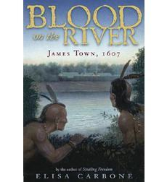
Now that we have finished reading the book, Blood on the River, it is important that you extend upon the knowledge you have gained, and decipher between what was real and what was fiction. Follow the directions below in order to complete one of the choices from the menu for your final project.

1. The settlers were not allowed to write letters saying anything bad about what it was like living in the New World. Yet, as we know from reading this historical novel, the settlers had many problems trying to start a new life in James Town. Imagine that you are a settler and your brother has sent word that he is coming to join you in James Town. Write him a 2 page truthful letter about your experiences in the New World, and convince him to stay in England.

2. Go back to the beginning of the book and analyze the prophecy line by line. Find the specific details/evidence in the story that lines up with the prophecy.

3. Create an illustrated timeline detailing at least 10 historically accurate events from the story. Remember, even though many of the events in the story really did occur, the genre of the book is historical fiction (meaning not everything is true). This requires you to do some research of the events before documenting them onto your timeline. Your timeline should include the year the event occurred, a photo relating to the event, and a detailed one-two sentence description of the event.

4. Choose one of the following Persuasive Essay writing exercises. Remember, essays must contain at least 4 paragraphs. Paragraphs must include an introduction, 2 body and supporting detail paragraphs, as well as a final conclusion paragraph.

a. Pretend you are Chief Powhatan. Write a letter persuading John Smith to abandon James Town and take the colonists back to England.

b. Pretend you are John Smith. Write a letter persuading Chief Powhatan to help the colonists survive while you are away seeking medical attention in England.

5. We know that Samuel Collier lived at the end of the book, but there are missing years in his life that this book does not cover. Write about him to continue his story, imagining what might have happened to him. This story should be at least 2 pages in length, and should be a realistic continuation of Samuel’s life.

** If you utilize the Internet or any other sources for information, quotes, or pictures/graphics, a list of books and websites used must be included with projects. **

